Red Star Warehouse, 2612 West Greves St, Milwaukee $1,300,000 414 - 559 - 5555

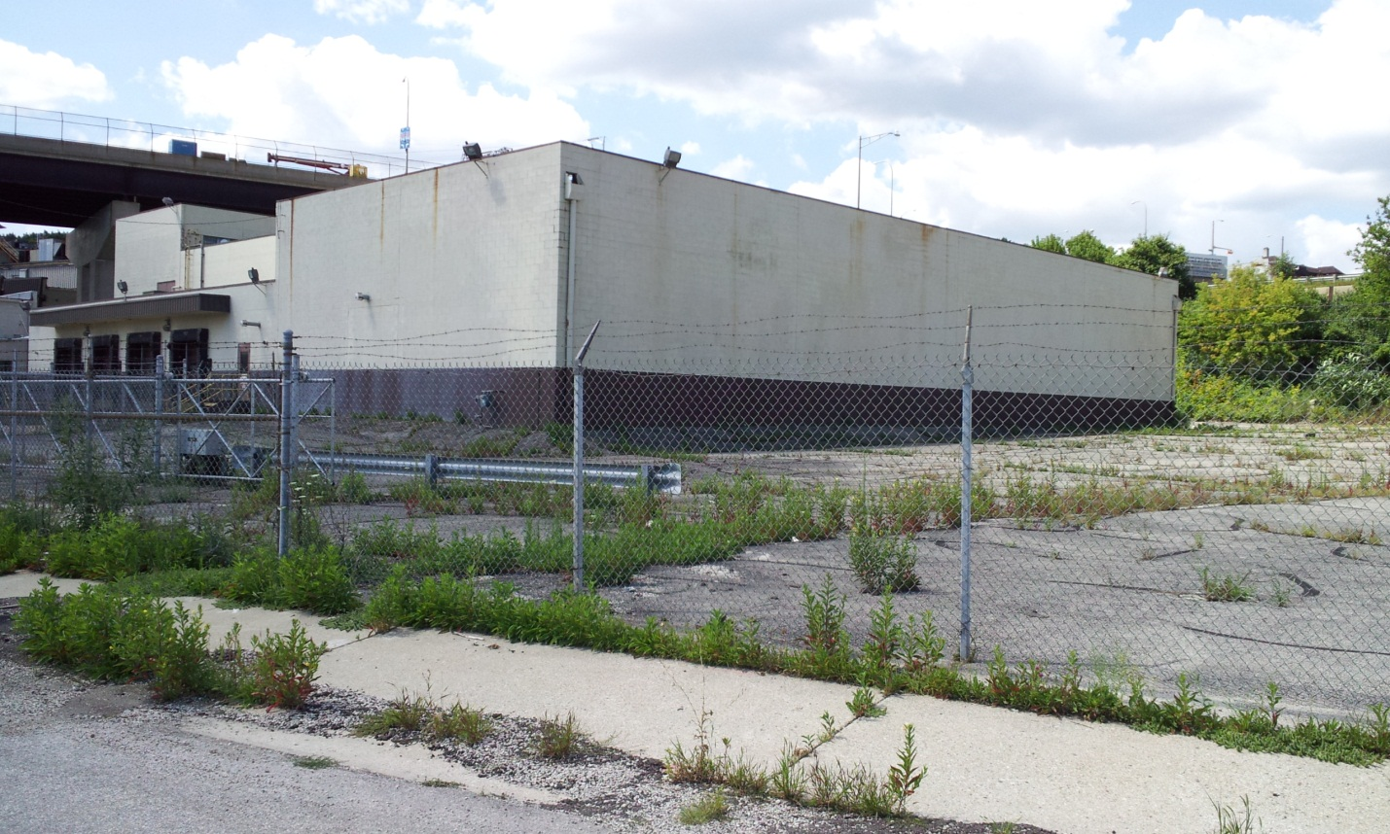

Main Building:
Food manufacturing - distribution warehouse, rack storage, up to 22 ft. clear.
Building is 36,300 square feet. The first floor is 26,700 sq.ft. plus 1600 sq.ft. mezzanine. There is also a second floor with 8000 sq.ft.
Refrigerated 5100 square foot section of the warehouse 20 feet high is insulated with pallet racks that can be used as a cooler or regular warehouse space.
4 excellent off street truck loading docks allow for easy loading.
4 drive in overhead doors. The building is in a fenced lot with a paved lot.

Building 2:
Building is 6800 square feet consisting of 5000 sq.ft. first floor and 1800 sq.ft. mezzanine.
1 truck dock, 4 drive in overhead doors
This building has a new metal roof deck with new insulation and new roof.

Location:
Approx. 3 acre site
Zoned - Heavy Industrial

Conveniently located in Milwaukee's Menomonee Valley, the north property line is along the I-94 freeway with a daily traffic count of 140,000 .

The west property line is along 27th Street ( HWY 57 ) with a daily traffic count of 15,000 . The interstate on and off ramps near the property allow quick access to and from the property.

Real Estate Taxes payable in 2016 : $33,269
